**DAILY ONLINE ACTIVITIES SUMMARY**

|  |  |  |  |  |  |  |
| --- | --- | --- | --- | --- | --- | --- |
| **Date:** | **01-06-2020** | | | **Name:** | **Sannidhi P** | |
| **Sem & Sec** | **8th sem B sec** | | | **USN:** | **4AL16CS084** | |
| **Online Test Summary** | | | | | | |
| **Subject** | | **SMS** | | | | |
| **Max. Marks** | | **60** | | **Score** | **15** | |
| **Certification Course Summary** | | | | | | |
| **Course** | **JAVASCRIPT Tutorial** | | | | | |
| **Certificate Provider** | | | **SOLOLEARN** | **Duration** | | **2hrs** |
| **Coding Challenges** | | | | | | |
| **Problem Statement: c program to print right angled triangle number star pattern** | | | | | | |
| **Status: completed** | | | | | | |
| **Uploaded the report in Github** | | | | **Yes** | | |
| **If yes Repository name** | | | | **sannidhi1** | | |
| **Uploaded the report in slack** | | | | **Yes** | | |

YOnline Test Details: (Attach the snapshot and briefly write the report for the same)

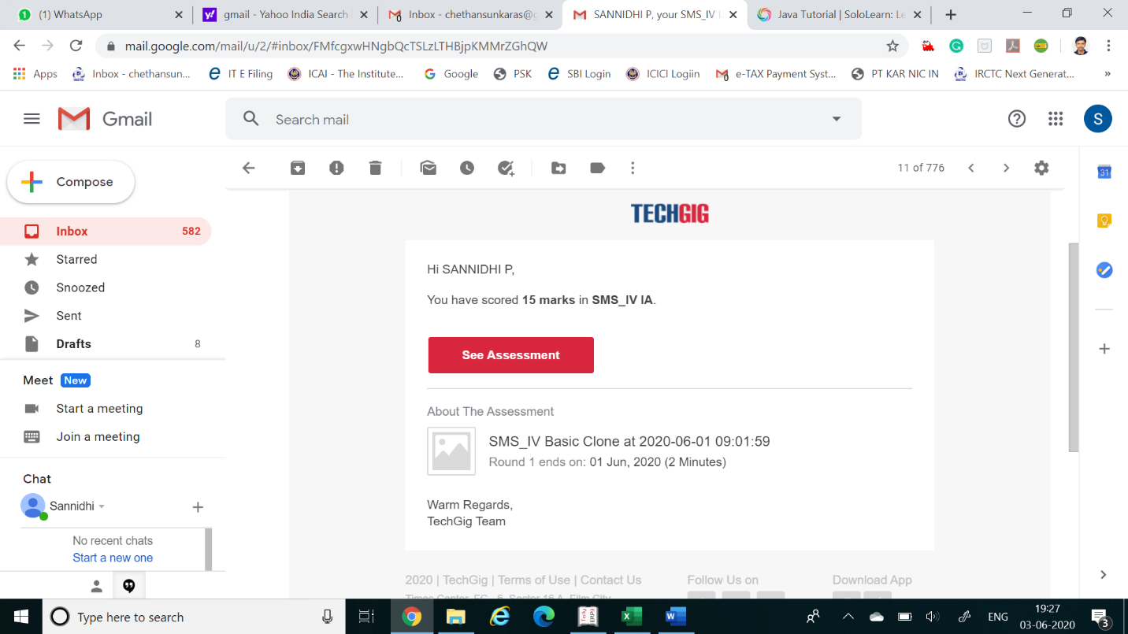

Certification Course Details: (Attach the snapshot and briefly write the report for the same)

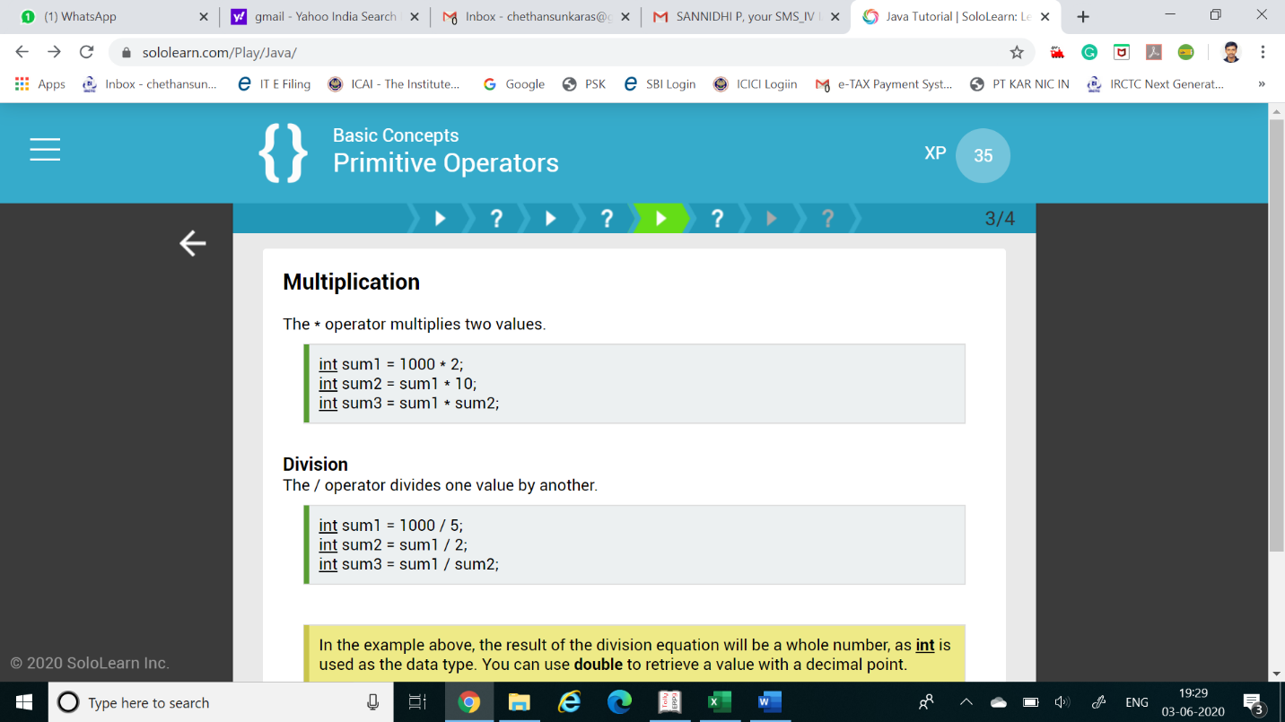

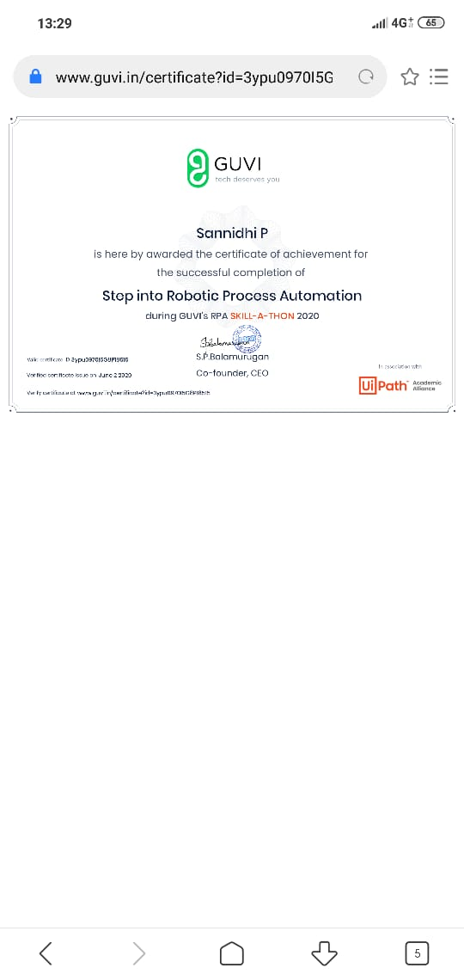

Coding Challenges Details: (Attach the snapshot and briefly write the report for the same)

Coding was given n it was uploaded for github and slack

**Program 1....**

**int main()**

**{**

**int rows,I,j;**

**Printf ("please enter the number of rows");**

**scanf("%d",&rows);**

**Printf("printing the pattern");**

**{**

**for(j=1;j<=I;j++)**

**{**

**Printf ("*");**

**}**

**Printf ("\n");**

**}**

**return 0;**

**}**